Name_________________________________ Date___________________________

Proxy Wars during the Cold War: Korea, Vietnam, and Afghanistan

Background: During the Cold War the United States and the Soviet Union (USSR) did not fight each other because of the Mutually Assured Destruction theory. They both knew that if Soviet and American soldiers killed each other, then their leaders would feel pressure to use nuclear weapons against each other, and this could lead to both sides being destroyed. Instead, the U.S. and USSR fought proxy wars. A Proxy War is when you get someone else’s soldiers to fight a war instead of your soldiers. For example: if the Soviet Union invaded a country, the U.S. would give that country money and weapons to fight the Soviet soldiers. If the United States invaded a country, the Soviet Union would give that country money and weapons to fight the American soldiers.

Your Task: While reading, explain how each of these three wars was an example of a proxy war and if this benefitted the U.S., Soviet Union, and the other nations involved.

- Korean War
Before WWII, Japan conquered Korea. To defeat Japan, the USSR invaded Korea from the North and the US invaded from the south. After the war, Korea was divided along the 38th Parallel temporarily, and would eventually elections to unify. But in North Korea, Kim Il Sung started a communist government and in South Korea, Syngman Rhee started a capitalist dictatorship. Each side claimed to be the government of ALL Korea. Kim Il Sung asked Joseph Stalin for help to attack South Korea. Stalin gave North Korea money & weapons, and on June 25, 1950, North Korea invaded South Korea. By September 14, 1950, the North Koreans had conquered almost all of Korea. So, South Korea asked the US for help and the U.S. sent soldiers to South Korea by November 25, 1950, they had pushed the North Koreans back almost to the Yalu River (see the maps below). However, North Korea had a new ally - in 1949, China had a Communist Revolution. In December, 1950, Stalin convinced China to send 300,000 Chinese soldiers into Korea to fight South Korea and the US. The war continued for 2 more years until an armistice (an agreement to stop fighting) was signed on July 27, 1953 and North and South Korea were divided in the same place as they started in 1945.
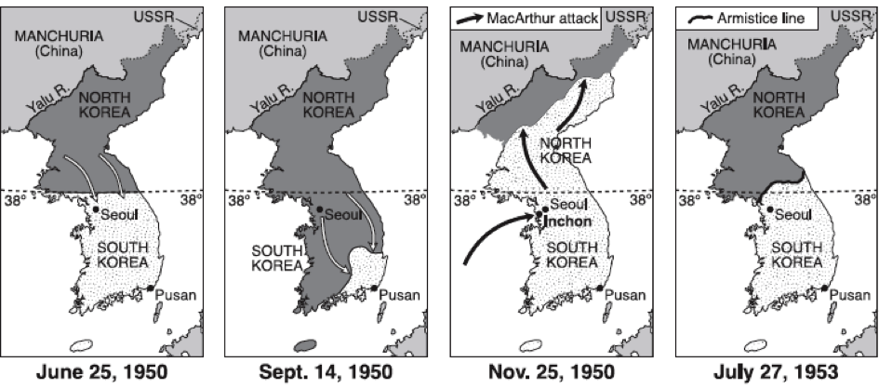

35,568 American soldiers, 600,000 Chinese soldiers, and over 2,000,000 Koreans died. The U.S. firebombed 18 of North Korea’s 22 cities, which caused North Korea to hate the United States to this day. However, Soviet fighter planes, with Soviet pilots, ended up shooting at American planes flown by American pilots. It was the only time this happened during the Cold War. The Soviet Union and the U.S. knew their planes had shot at each other, but at the time, neither Stalin or the U.S. Presidents (Truman and Eisenhower) admitted this happened.

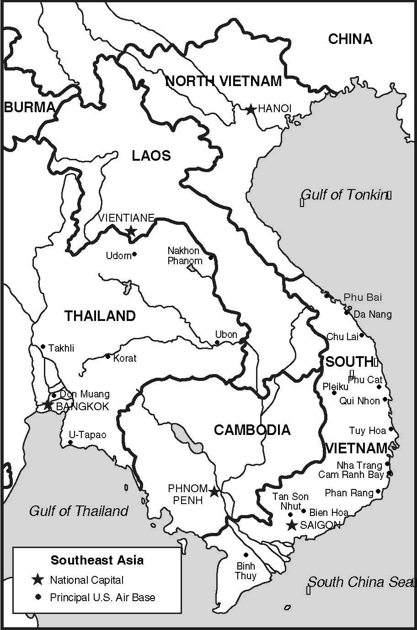
2) The Vietnam War

Vietnam was a French colony from the 1800s to 1954. When it became independent, it was divided into a North and South. North Vietnam was Communist, led by Ho Chi Minh. South Vietnam was capitalist, led by Ngo Din Diem, who oppressed the South Vietnamese Communists, so North Vietnam invaded the South in 1961. The U.S. was afraid of Vietnam being controlled by the Soviet Union and China, so from 1960-1973, the U.S. sent 2,700,000 soldiers to fight the North Vietnamese. The Soviet Union and China wanted to weaken the United States, so they sent weapons, supplies, and soldiers to help North Vietnam.

58,000 U.S. soldiers and 3,000,000 Vietnamese died in this war. In 1973, the U.S. removed its soldiers and gave up. In 1975, North Vietnam defeated the South, unified the country into one, communist nation called “Vietnam”. They are still Communist.

3) The Soviet-Afghan War
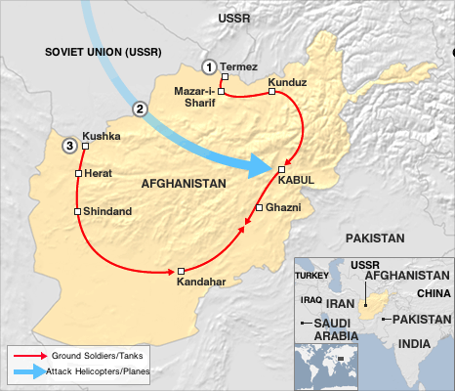
In 1979, the Soviet Union invaded Afghanistan because the Afghan Communist government asked for the USSR’s help fighting against a rebellion. The Soviet Union invaded and caused huge damage and death to Afghanistan.

U.S. Congressman Charlie Wilson convinced the U.S. Government to spend billions of dollars on a covert (secret) plan to give anti-aircraft weapons to Pakistan who would then give them to the Afghan freedom fighters (called Mujahideen) who would use them to better attack the Soviet helicopters and aircraft.

By 1988, the Soviet Union had lost 333 helicopters, 118 planes, 147 tanks, and 14,000 soldiers. They gave up and left Afghanistan. But there were problems in Afghanistan that the war did not fix:
- Roads, schools, hospitals, and homes in Afghanistan was destroyed, but the U.S. did not help rebuild Afghanistan the way they rebuilt Europe with the Marshall Plan.
- Many Mujahideen came from other Muslim countries and had a traditional view of Islam (like ISIS). In 1992, a Mujahideen fighter named Osama bin Laden created the terrorist group Al Qaeda. In 1996, a Mujahideen group called the Taliban took over Afghanistan’s gov’t.

The Mujahideen did not know that the U.S. had helped them, because all the weapons came to them from Pakistan. Osama Bin Laden felt that the U.S. was no different from the Soviet Union by attacking weaker nations (like Korea, Vietnam, and many Muslim countries), and most Mujahideen felt that they were powerful enough to defeat the USSR, so they could also defeat the U.S. From 1992-2001, Al Qaeda planned attacks on the U.S. and succeeded a few times in attacking U.S. soldiers in the Middle East, East Africa, and lastly, using hijacked planes to crash into the World Trade Center and the Pentagon on September 11, 2001.

