Name_______________________________ Date________________________
Map of Queen Europa
Historical Context: Sebastian Munster drew this map in 1588. The perspective is Europe as a “queen” during the Renaissance. What biases does this map show? What was Munster’s motive for making it?
Directions: Wherever you see biases, write a “B” and words describing the bias. Also, explain the possible motives for making a map like this (wherever you have free space). (Extra credit is on the back)
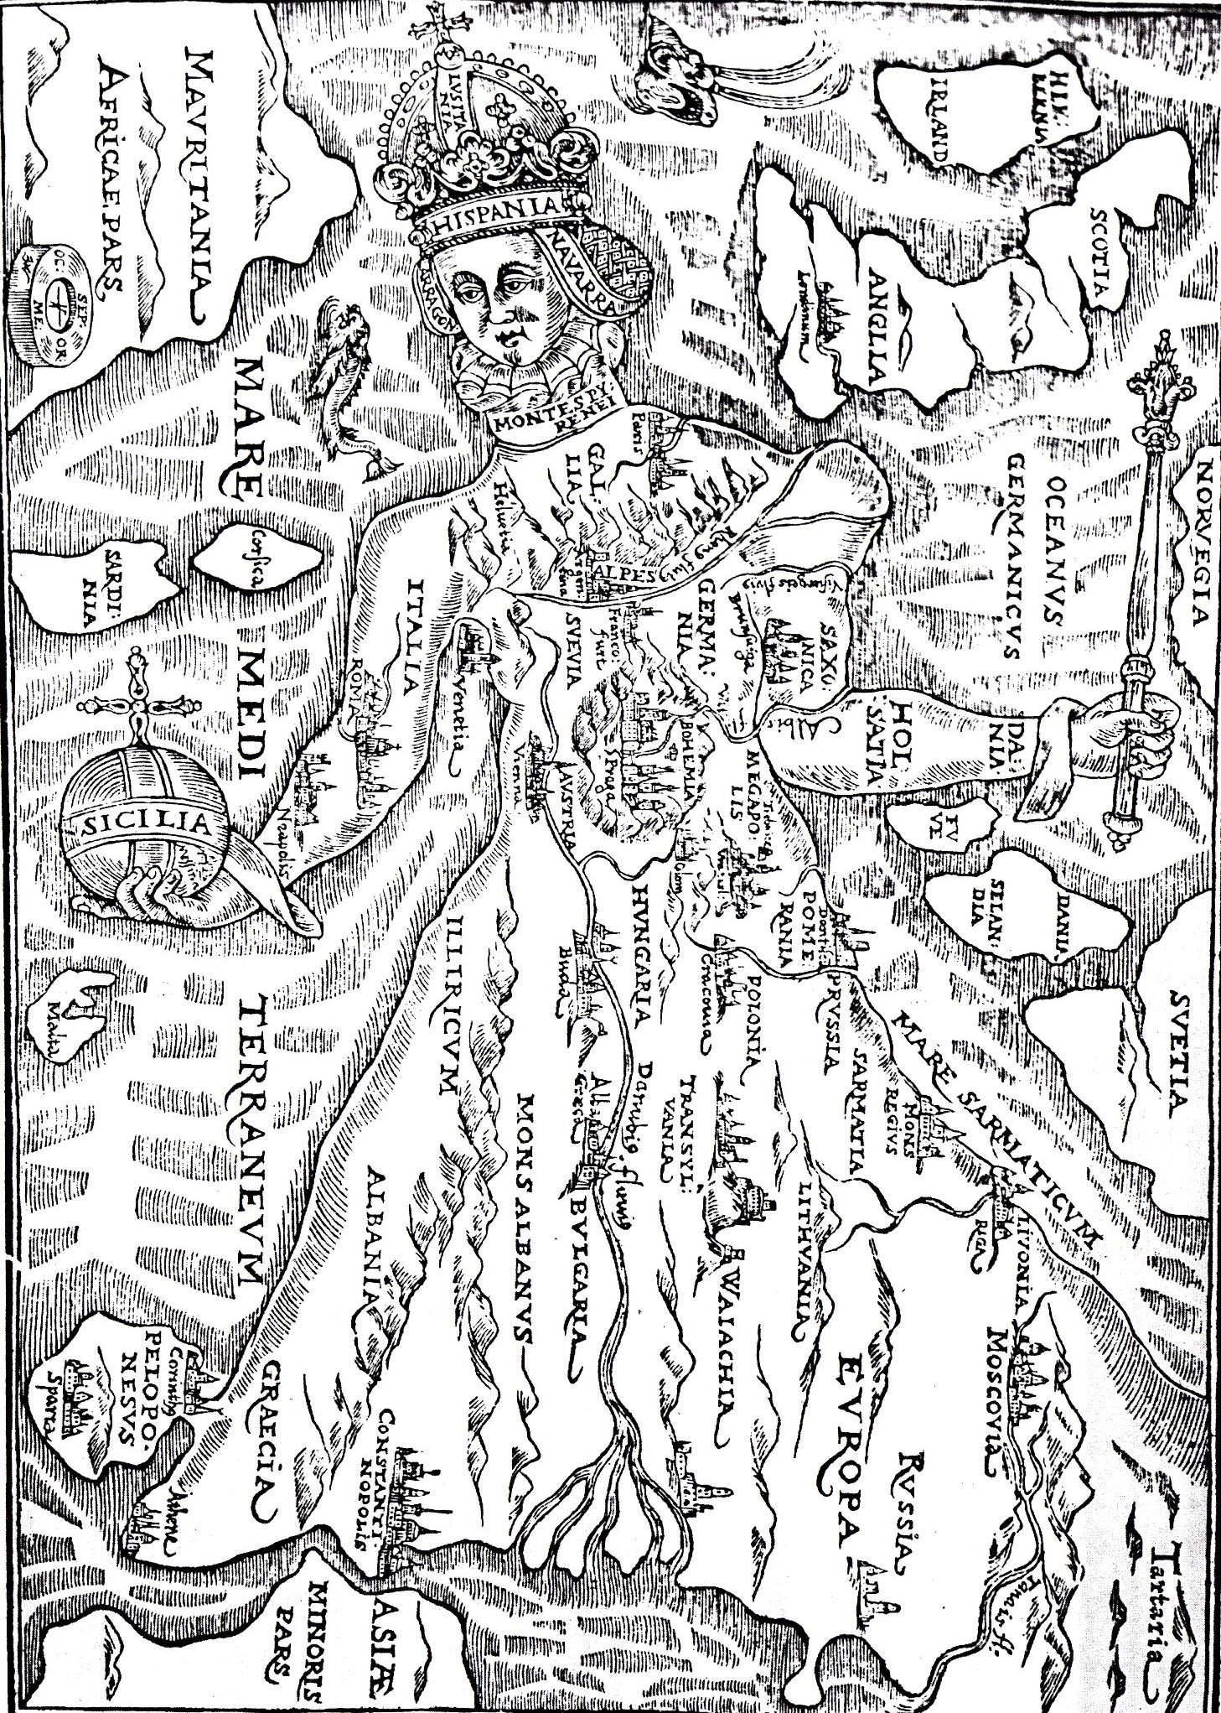
Extra Credit: The perspective of the previous map is the location of cities and countries in Europe in the late 1500s. The map below is what Europe actually looked like in 1588. Most of Europe was controlled by the Spanish King Charles V, and he was from the Habsburg family. They also had land in Northern Europe (The Netherlands), Central Europe (The Holy Roman Empire/Germany), Eastern Europe (Austria) and Southern Europe (Italy). Below is a list of the names of the cities today. Match these names with names from the previous map. The first one is done for you as an example:
Europe Map in 1588 Queen Europa Map
- London 1) Londinum
- Paris 2) __________
- Venice 3) __________
- Rome 4) __________
- Naples 5) __________
- Riga 6) __________
- Moscow 7) __________
- Prague 8) __________
- Vienna 9) __________
- Krakow 10) __________
- Budapest 11) __________
- Athens 12) __________
- Sparta 13) __________
- Constantinople 14) __________
