“The World’s Plunderers”
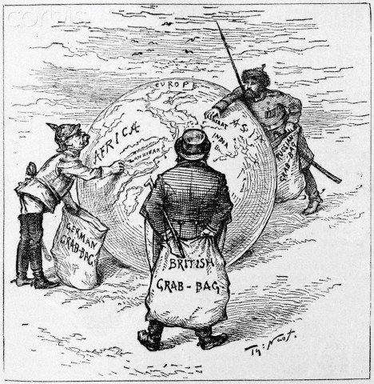
by Thomas Nast, Harper’s Weekly 1885

- What are the important objects in the cartoon, and what do they represent?

- Who are the main figures in the cartoon, and who do they represent?

- What are the important actions in the cartoon, and what do they represent?

- How do you think the artist feels about “The World’s Plunderers?”

5. What could be another title for this cartoon?

